Name: | ___________________________________________________ |  |  | Date: ___________
 | Year 9 Mathematics  Test 8, 2015  Topic – Linear Equations and Graphs |  |  | 60  = %
Total Time: | 64 minutes
Total Reading: | 4 minutes
Total Working: | 60 minutes
SECTION 1: CALCULATOR FREE
Time: | 20 minutes | Marks for Section 1: | 18
Reading: | 2 minutes | Equipment Allowed: | Nil
Working: | 18 minutes

1. | [3 marks: 1, 1, 1]
 | Circle the correct answer:
a) | What is the correct general form for a linear equation:
 | i) ii) iii) iv)
b) | A line with a gradient of -2 and a y-intercept of -1 would have an equation of:
 | i) ii) iii) iv)
c) | The graph of the rule , would be a ________________line?
 | i) sloping ii) vertical iii) curved iv) horizontal
2. | [4 marks: 1, 1, 1, 1]
a) | Match the each graph to one of the equations below:
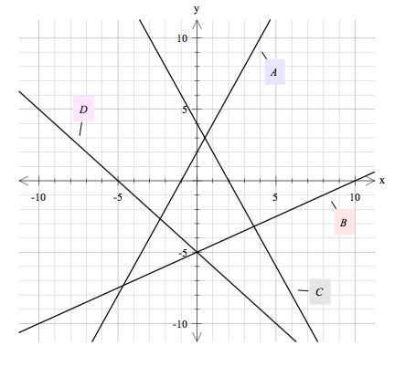

Equation
Graph

3. | [2 marks: 1, 1]
 | Write down the equation of each of these lines:
a) | 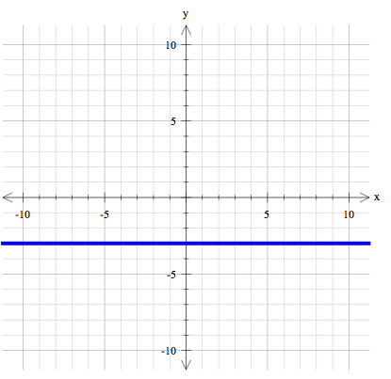 | b) | 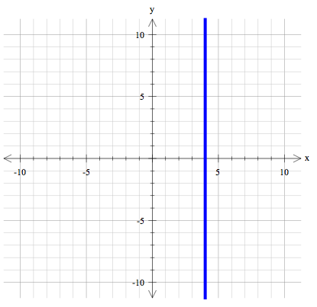

4. | [3 marks: 1, 2]
 | Complete the table using the given rule, then plot on the Cartesian Plane:
 | -3 -2 -1 0 1 2 3
 | 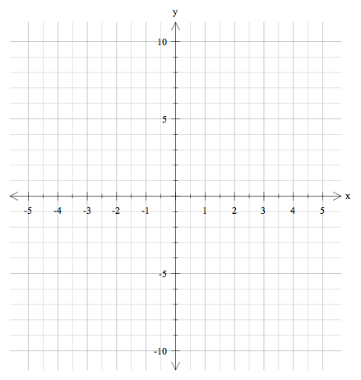

5. | [6 marks: 1, 1, 2, 2]
 | Solve the following linear equations
a) |  | b)
c) |  | d)

~ END OF SECTION 1 ~
Name: | ______________________________________ |  |  | Date: ___________
SECTION 2: CALCULATOR ASSUMED
Time: | 44 minutes | Marks for Section 2: | 42
Reading: | 2 minutes | Equipment Allowed: | ½ page notes (A4 one side),  CAS calculator
Working: | 42 minutes

6. | [12 marks: 2, 2, 2, 2, 2, 2]
 | Solve the following linear equations:
a) |  | b)
c) |  | d)
e) |  | f)

7. | [4 marks: 2, 2]
 | Write the rule that relates y to x for each of the following table of values:
a) | x 0 1 2 3 4  y 10 6 2 -2 -6
b) | x 1 2 3 4 5  y -7 -3 1 5 9
8. | [4 marks: 2, 2]
 | Identify the gradient and y-intercept for each of these equations:
 | Equation Gradient y-intercept

9. | [3 Marks]  Graph the line for the equation: , using any suitable method.  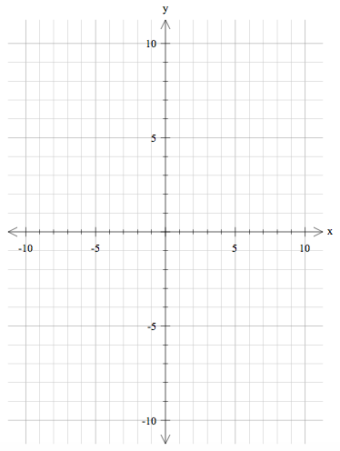

10. | [2 marks: 1, 1]
 | Find the gradient of the lines passing through the following pairs of points:
a) | (3, -2) and (-1, 6) | b) | (-4, -7) and (1, -1)

11. | [4 marks: 2, 2]
 | Write the equation for each of the following lines:
a) | 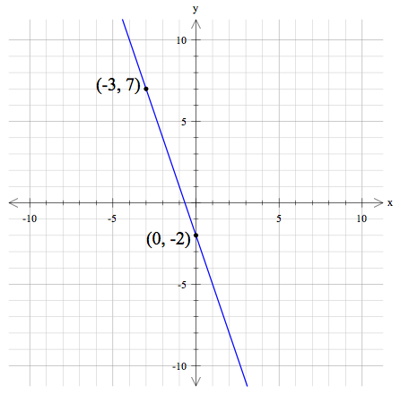 | b) | 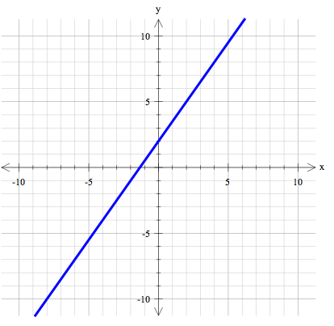

12. | [7 marks: 1, 2, 2, 2]
 | Find the equation for the straight line with:
a) | Gradient = -4 and passing through the origin
b) | Gradient = 3 and passing through the point (-2, -4)
c) | Gradient = and x-intercept = -4
d) | Gradient = and passing through the point (-2, 5)
13. |  | [6 marks: 2, 2, 2]
 |  | A hot air balloon descends (goes down) at a constant rate so that its height is 600 m after 30 seconds and after 60 seconds its height is 480 m.
a) |  | Find the equation of the line that relates the height (h) of the balloon in metres and the time (t) in seconds.
b) |  | Use the equation to find the height of the balloon after 2 minutes
c) |  | Use the equation to show how long it takes for the balloon to return to the ground.

~ END OF SECTION 2 ~

